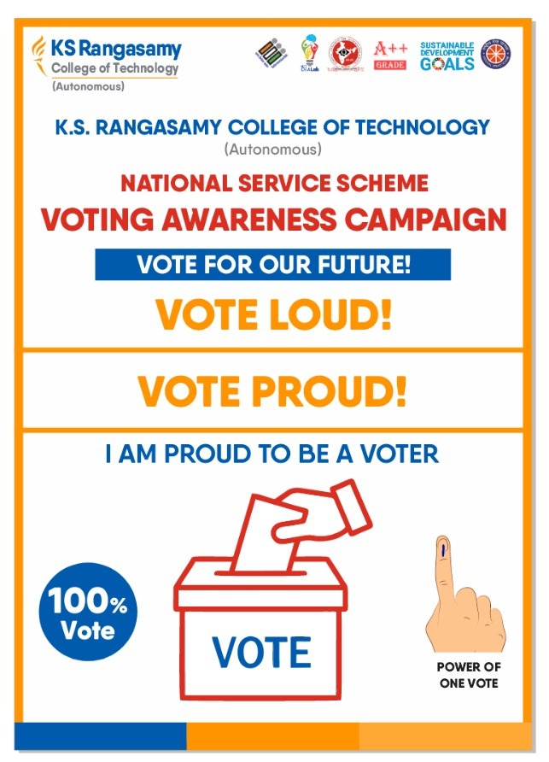

|  |  |  |
| --- | --- | --- |
| Registration Closed | K.S.Rangasamy College of Technology | **K.S.RANGASAMY COLLEGE OF TECHNOLOGY**  **(Autonomous)**  **TIRUCHENODE – 637215, NAMMAKAL**  **TAMIL NADU, INDIA** | Image result for nss symbol |
| Image 1Image result for nba accrediatedImage result for aicteKSRCT – IdeaLab – Empowering Innovation for a Brighter Tomorrow!Image 1Image result for naac a++ logo | | |

|  |  |  |
| --- | --- | --- |
| Event Name | **:** | VOTERS AWARENESS RALLY |
| Event Date / Time in Hrs | **:** | 18.04.2024 |
| Place | **:** | **K.S. RANGASAMY COLLEGE OF TECHNOLOGY**  **(Autonomous)**  **TIRUCHENODE** |
| Taluk, District, State | **:** | **TIRUCHENODE – 637215, NAMMAKAL**  **TAMIL NADU, INDIA** |
| No of Beneficiaries | **:** | **100** |
| No of NSS volunteers | **:** | **50** |
| No of Hours involved | **:** | **6 hrs** |
| Signature of NSS PO(s)  With Name | : |  |

|  |  |  |
| --- | --- | --- |
| **Event Report** | **:** |  |
| **PHOTOS** |  |  |